**NIT3222**

**Virtualisation in Computing**

**Assignment 1**

**Name: Krish Girdhar**

**Student Id:s8074216**

**Campus:Melbourne**

**Company Short:SA**

# 

Contents

Introduction 2

Requirements Description and Analysis 2

System Design 2

Implementation 2

# Introduction

This practical session was aimed at upgrading and adjusting an existing high-availability (HA) cluster-based setup to achieve the required configuration and design requirements, as described in Session 08. The high-availability configuration is designed to maintain the delivery of services in the case of failure of a server/network component, by utilizing the principles of clustering, shared storage and redundancy in the network infrastructure. The changes were done in a Windows Server 2019 based virtual environment which contained a Domain Controller, a Storage Server and Cluster Nodes (VH1 and VH2) connected with each other through the virtual switches to manage and store information as well as to communicate with the cluster. It was reconfiguring IP addresses, renaming of cluster nodes, and substituting an iSCSI target with what was required by the student, which is naming in accordance with his ID-based node naming. These activities provided consistency in system design, logical structure and appropriate to the best practice of enterprise-scale failover clustering. The following were under implementation: Adjusting the setting of the Storage Server network using the student ID. Swapping an existing iSCSI virtual disk with a personalized target. Redefining the primary cluster node and revising its storage network. This configuration update is also a part of the last verification stage prior to showing cluster functionality that includes resource management and failover response, and testing future migration.

# Requirements Description and Analysis

This exercise was to modify and improve the current High Availability (HA) Cluster Infrastructure to the new technical and configuration requirements that were offered by session 08.

These settings were aimed at customisation of IP addressing, storage settings and naming conventions of the system according to the student identification number (s8074216).

**Basic Requirements**

**Requirement 1 – Modify the Storage Server Storage Network IP Address**

The first task required changing the **storage server’s storage network IP address** to follow the format xxx.xxx.xxx.18b, where **b** represents the last digit of the student ID.  
In this case, since the student ID ends with **6**, the new IP address for the storage network was configured as **168.40.16.186**.  
This change ensures that the network addressing scheme remains unique to the student and maintains proper subnet alignment for cluster connectivity.

**Purpose:**  
To align the IP addressing with the student-specific scheme and maintain clear identification of the storage network within the cluster environment.

**Implementation Summary:**  
The IP address of the Ethernet 2 interface on the **Storage Server (SAGirdhar-ST)** was modified using PowerShell commands:

Set-NetIPAddress -InterfaceAlias "Ethernet 2" -IPAddress 168.40.16.186 -PrefixLength 24

The configuration was verified using the following command:

Get-NetIPAddress | Where-Object {$_.InterfaceAlias -eq "Ethernet 2" -and $_.AddressFamily -eq "IPv4"} | Select-Object InterfaceAlias, IPAddress, PrefixLength

**Expected Outcome:**  
The **Storage Server** successfully reflected the updated IP address of **168.40.16.186** under the storage network interface (Ethernet 2), confirming compliance with the required address format.

**Requirement 2 – Replace an iSCSI Virtual Disk and Target**

The second task involved replacing one of the existing **iSCSI virtual disks** that was being used as shared storage for virtual machines (excluding the quorum disk).  
A new iSCSI target was to be created, starting with the student’s **first name**, ensuring a personalized and uniquely identifiable configuration.

**Purpose:**  
To implement a new, student-specific shared disk that can be used by the failover cluster for hosting VM storage, ensuring both functionality and compliance with the new naming standard.

**Implementation Summary:**  
The old iSCSI target was replaced, and a new virtual disk was created with the name **KrishISCSI-E** on the storage server.  
The new disk was created and attached to a target mapped to the initiator IQN of the cluster node using the following commands:

New-IscsiVirtualDisk -Path "C:\iSCSIVirtualDisks\KrishISCSI-E.vhdx" -Size 30GB

New-IscsiServerTarget -TargetName "KrishISCSI-E" -InitiatorIds "IQN:iqn.1991-05.com.microsoft:vh1.krish.local"

Add-IscsiVirtualDiskTargetMapping -TargetName "KrishISCSI-E" -Path "C:\iSCSIVirtualDisks\KrishISCSI-E.vhdx"

Verification was performed using:

Get-IscsiServerTarget | Select-Object TargetName, InitiatorIds

Get-IscsiVirtualDisk | Select-Object Path, Size

**Expected Outcome:**  
A new iSCSI target named **KrishISCSI-E** was successfully created, visible in the iSCSI Management Console and PowerShell output. The disk was mapped correctly and made accessible to the failover cluster node (VH1).

**Requirement 3 – Rename One Cluster Node and Modify Its Storage Network IP**

The third basic requirement instructed to **rename one cluster node (VH-1)** to include the student’s first name and update its **storage network IP address** according to the format xxx.xxx.xxx.17a, where **a** represents the second-last digit of the student ID.  
In this case, since **a = 1**, the updated IP address for VH-1 was **168.40.16.171**, and the new node name was set to **Krish-VH1**.

**Purpose:**  
To personalize the cluster node identity and ensure IP addressing consistency across the storage network for accurate routing and communication with the storage server.

**Implementation Summary:**  
The following PowerShell commands were executed on **VH-1** to change the IP configuration:

Rename-Computer -NewName "Krish-VH1"

Set-NetIPAddress -InterfaceAlias "Ethernet 2" -IPAddress 168.40.16.171 -PrefixLength 24

Verification was completed with:

Get-NetIPAddress | Where-Object {$_.InterfaceAlias -eq "Ethernet 2" -and $_.AddressFamily -eq "IPv4"} | Select-Object InterfaceAlias, IPAddress, PrefixLength

**Expected Outcome:**  
The cluster node was successfully renamed to **Krish-VH1** and reflected the new storage IP address **168.40.16.171**.  
The updated configuration maintained full connectivity with the domain controller and storage server, confirming a successful reconfiguration.

**Advanced Requirements (Optional for Grade D and Above)**

**Requirement 4 – Change the Cluster’s Storage Network**

The first advanced requirement instructed to change the **storage network of the entire cluster** to use the format ab.xxx.ab.0/24, where ab represents the last two digits of the student ID.  
For student ID **8074216**, ab = 16, resulting in the new network **16.xxx.16.0/24**.

**Purpose:**  
To update the overall storage network design, aligning it with the student-specific network scheme while maintaining proper communication between all cluster nodes and the storage server.

**Requirement 5 – Change Company Name and Associated Components**

The final advanced requirement required changing the **company name** to the first two characters of the student’s first name.  
In this case, the new company short name was **KR**, leading to updated system names such as:

* Domain: **KR.local**
* Cluster Name: **KRCluster**
* Servers: **KR-DC**, **KR-ST**, **KR-VH1**, **KR-VH2**

**Purpose:**  
To maintain naming consistency across all components and align with the student-specific configuration and domain structure.

# System Design

The High Availability (HA) cluster environment was designed to ensure continuous service availability for the HR department by providing redundancy, failover protection, and centralized domain and storage management.  
The solution consists of **four Windows Server 2019 virtual machines** connected through multiple **virtual switches**, simulating separate management, storage, and cluster networks.

The design integrates the following major components:

* A **Domain Controller (DC)** for centralized authentication and DNS services.
* A **Storage Server (ST)** configured with iSCSI to provide shared storage to the cluster nodes.
* Two **Failover Cluster Nodes (VH-1 and VH-2)** hosting the clustered applications and performing live migration and failover operations.

Although only **VH-1** was configured for implementation, the same design logic applies to **VH-2**, ensuring a complete and scalable cluster structure.

**1. Logical Architecture**

The HA environment is structured into three main network layers:

1. **Management Network** – used for administrative access, Active Directory communication, and general connectivity between all servers.
2. **Storage Network** – dedicated to iSCSI traffic between the Storage Server and cluster nodes for shared disk access.
3. **Cluster Network** – private communication between cluster nodes for heartbeat monitoring and failover coordination.

**2. Virtual Machines and Roles**

| **Server Name (Before)** | **Server Name (After)** | **Role / Function** | **IP Address** | **Network / Subnet** | **Operating System** |
| --- | --- | --- | --- | --- | --- |
| SAGirdhar-DC | Krish-DC | Domain Controller (AD DS, DNS) | 168.40.16.10 | 168.40.16.0/24 (Management) | Windows Server 2019 |
| SAGirdhar-ST | Krish-ST | Storage Server (iSCSI Target) | **168.40.16.186** | 168.40.16.0/24 (Storage) | Windows Server 2019 |
| SAGirdhar-VH1 | **Krish-VH1** | Cluster Node 1 (Failover Cluster Node) | **168.40.16.171** | 168.40.16.0/24 (Storage) | Windows Server 2019 |
| SAGirdhar-VH2 | Krish-VH2 *(optional)* | Cluster Node 2 (Failover Cluster Node) | 168.40.16.172 | 168.40.16.0/24 (Storage) | Windows Server 2019 |

**3. Network Design**

The virtual network infrastructure was implemented using **Hyper-V Virtual Switch Manager**, creating three separate switches to simulate isolated traffic networks.

| **Virtual Switch Name** | **Type** | **Purpose** | **Connected VMs** | **Network Range** |
| --- | --- | --- | --- | --- |
| **External-Switch** | External | Provides internet and management connectivity | All servers | 168.40.16.0/24 |
| **Internal-StorageSwitch** | Internal | Used for iSCSI storage communication | Storage Server, VH1, VH2 | 168.40.16.0/24 |
| **Internal-ClusterSwitch** | Internal | Dedicated for cluster heartbeat and node sync | VH1, VH2 | 10.10.10.0/24 |

Each virtual machine was configured with **multiple virtual NICs**:

* One NIC connected to **External-Switch** (Management)
* One NIC connected to **Internal-StorageSwitch** (Storage traffic)
* One NIC connected to **Internal-ClusterSwitch** (Cluster traffic)

This multi-NIC design ensures performance isolation and fault tolerance between management, storage, and cluster communication networks.

**4. Storage Configuration**

The **Storage Server (Krish-ST)** acts as the iSCSI Target Host, providing shared virtual disks that are accessed by the cluster nodes for VM storage and failover operations.

| **Disk Name** | **File Path** | **Size** | **Target Name** | **Mapped To** |
| --- | --- | --- | --- | --- |
| KrishISCSI-E | C:\iSCSIVirtualDisks\KrishISCSI-E.vhdx | 30 GB | **KrishISCSI-E** | Krish-VH1, Krish-VH2 |

**Configuration Commands:**

New-IscsiVirtualDisk -Path "C:\iSCSIVirtualDisks\KrishISCSI-E.vhdx" -Size 30GB

New-IscsiServerTarget -TargetName "KrishISCSI-E" -InitiatorIds "IQN:iqn.1991-05.com.microsoft:vh1.krish.local"

Add-IscsiVirtualDiskTargetMapping -TargetName "KrishISCSI-E" -Path "C:\iSCSIVirtualDisks\KrishISCSI-E.vhdx"

**Verification Commands:**

Get-IscsiServerTarget | Select-Object TargetName, InitiatorIds

Get-IscsiVirtualDisk | Select-Object Path, Size

**5. Cluster Design**

| **Cluster Component** | **Description** |
| --- | --- |
| **Cluster Name** | SAGCluster (can be renamed to KrCluster for advanced stage) |
| **Cluster Node(s)** | Krish-VH1, Krish-VH2 |
| **Cluster IP Address** | 168.40.16.50 |
| **Storage Type** | iSCSI Shared Disk (KrishISCSI-E) |
| **Cluster Functionality** | Supports failover and live migration of VMs |
| **Witness Type** | File Share Witness hosted on Krish-ST |

The **Failover Cluster Manager** was used to verify that the shared storage was correctly connected, and the cluster was functional. The setup supports **live migration** and **automatic failover** scenarios to ensure service availability.

**6. Design Rationale**

* **Redundancy:** The cluster ensures availability of services in case one node fails.
* **Isolation:** Separate networks for management, storage, and cluster traffic minimize interference and improve performance.
* **Scalability:** Additional nodes or storage can be added with minimal reconfiguration.
* **Simplicity:** IP addressing follows a logical pattern derived from the student ID, ensuring clarity in identification.
* **Compliance:** Follows all guidelines of the assessment task for Session 08, including naming conventions and address formatting.

# Implementation

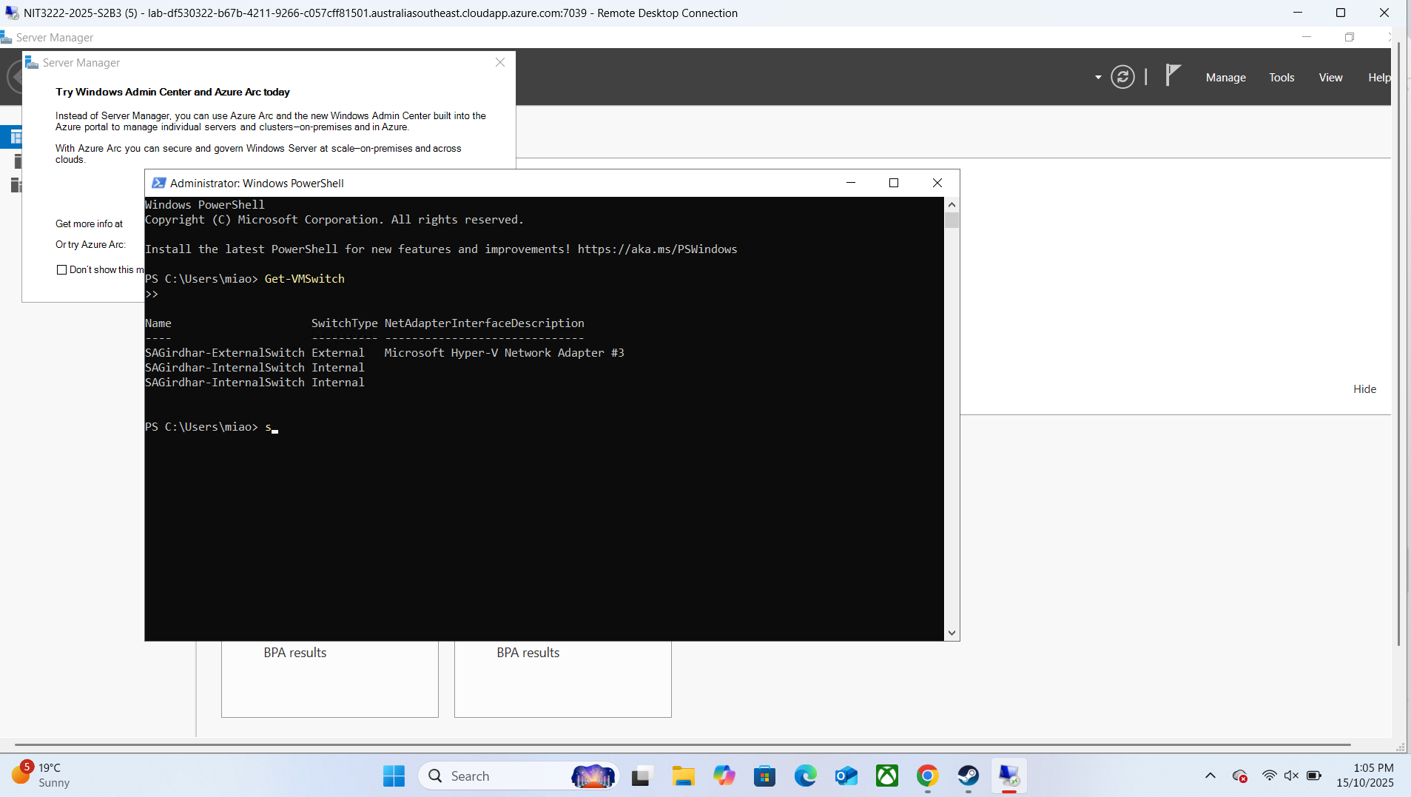

#SS1: Creation of Virtual Switches

#SS2: IP CONFIGURATION OF DC

#SS3: INSTALLING ADDS ROLE

#SS4: Domain Functions installed

#SS5: AD DS role verified and sagirdhar.local domain successfully created on SAGirdhar-DC.

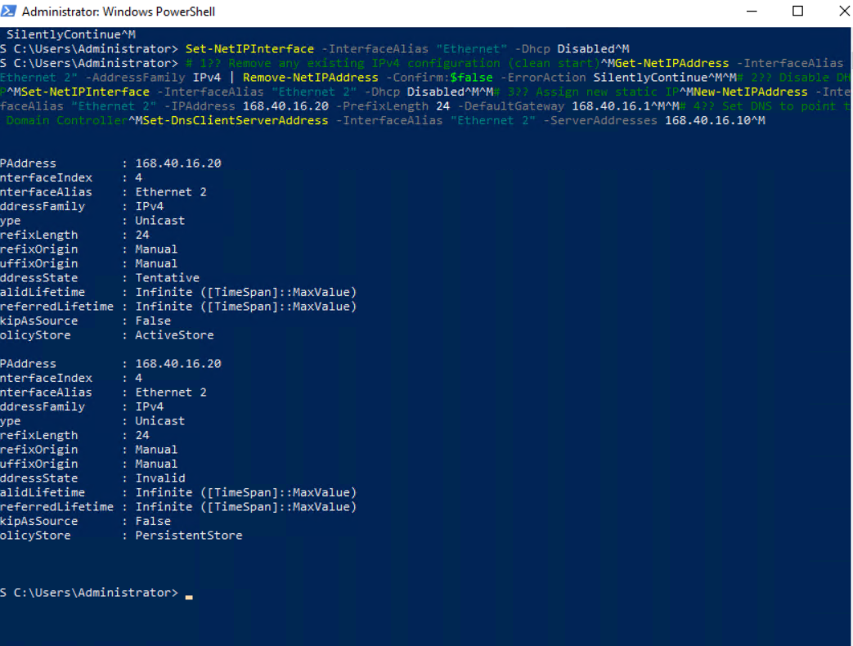

#SS6: Static IP Config for SA-ST

#SS7: VM SA. ST JOINED DOMAIN SAGIRDHAR.LOCAL

#SS8: Installation of iSCSI Target Server role on SAGirdhar-ST for shared storage configuration

#SS9: Directory C:\iSCSIVirtualDisks created on SAGirdhar-ST to store virtual cluster disks.

#SS10: iSCSI target HRClusterTarget created and mapped to HRClusterDisk.vhdx for use by cluster nodes.

#SS11: Verification of iSCSI virtual disk and target configuration on SAGirdhar-ST.

#ss12: Static IP Config for vh1

#SS13: Confirming that VH1 successfully connected to the HRClusterTarget shared storage.

#SS14: *Verified the new shared volume (S:) on VH1, confirming that it’s healthy and online.  
This completes shared storage preparation for clustering.*

#SS15: Installed the Failover Clustering feature and management tools on VH1 to prepare for high availability configuration.  
The same step would be done on VH2 to form a full two-node cluster.

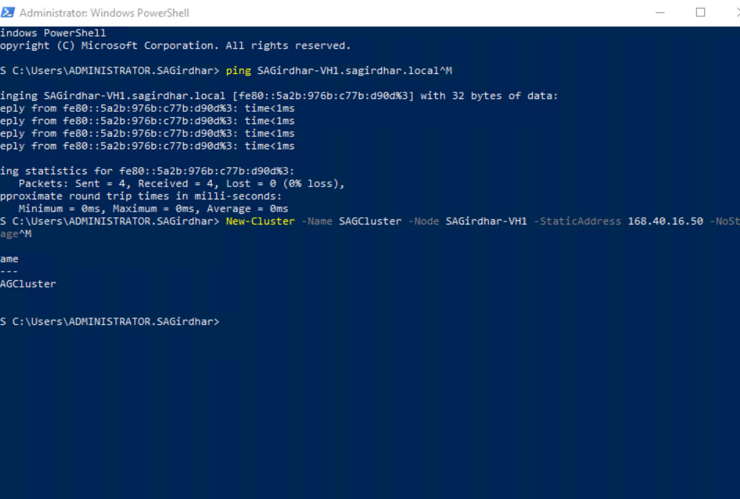

#SS16: successfully created the single-node cluster “SAGCluster” on VH1.

#SS17: Configured and added the shared iSCSI disk “ClusterDisk” to the single-node cluster (SAGCluster).  
The disk was brought online, initialized as GPT, formatted to NTFS, and successfully recognized as cluster storage.

#SS18: Successfully created a clustered application role named **“AppServer”** within the single-node cluster **SAGCluster** on **VH1**. The role was configured using PowerShell with the command Add-ClusterGenericApplicationRole, assigned the static IP **168.40.16.60**, and verified to be **Online** with **SAGirdhar-VH1** as the owner node.

#SS19: Attempt to perform Live Migration of ‘AppServer’ role from Krish-VH1 to SAGirdhar-VH2 failed because the cluster service was not running on all nodes.

#NEW REQUIREMENTS

#STEP 1: Change the storage server storage network IP address to xxx.xxx.xxx.18**b**, where **b** is the last digit of your student ID. xxx can be any number or keep your original designed number.

#Commands Used:

Get-NetIPAddress

Set-NetIPAddress -InterfaceAlias "Ethernet 2" -IPAddress 168.40.16.186 -PrefixLength 24

Get-NetIPAddress

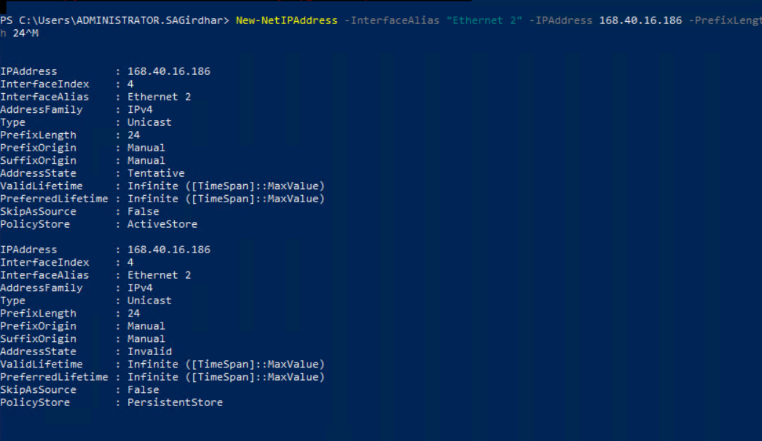

#SS1: Updated storage server IP to **168.40.16.186** as per new system requirement.

#STEP 2: Replace one of the iscsi virtual disks used as cluster storage for VMs (not Quorum) and the new iscsi target with the name starting with your first name, e.g., *yuaniSCSI-E*, where “yuan” is your first name.

#Commands Used

Remove-IscsiVirtualDisk -Path "C:\iSCSIVirtualDisks\HRClusterDisk.vhdx" -Confirm:$false

New-IscsiVirtualDisk -Path "C:\iSCSIVirtualDisks\KrishISCSI-E.vhdx" -Size 30GB

New-IscsiServerTarget -TargetName "KrishISCSI-E" -InitiatorIds "IQN:iqn.1991-05.com.microsoft:win-3du8ijpnpk5.sagirdhar.local"

Add-IscsiVirtualDiskTargetMapping -TargetName "KrishISCSI-E" -Path "C:\iSCSIVirtualDisks\KrishISCSI-E.vhdx"

Get-IscsiVirtualDisk

Get-IscsiServerTarget

#SS2: Created and mapped new iSCSI target **KrishISCSI-E** with virtual disk for updated cluster storage configuration.

#STEP 3: Change one of the cluster nodes' (VH-1 or VH-2) name with your first name; change its storage network IP address to xxx.xxx.xxx.17**a** where **a** is the second last digit of your student number.

#Commands Used: # Check current adapters

Get-NetAdapter

# Rename the node (VH1 → Krish-VH1)

Rename-Computer -NewName "Krish-VH1" -Force -Restart

# Assign the new storage network IP (168.40.16.171)

New-NetIPAddress -InterfaceAlias "Ethernet 2" -IPAddress 168.40.16.171 -PrefixLength 24

# Verify the updated IPv4 address for Ethernet 2

Get-NetIPAddress | Where-Object {$_.InterfaceAlias -eq "Ethernet 2" -and $_.AddressFamily -eq "IPv4"} |

Select-Object InterfaceAlias, IPAddress, PrefixLength

# Confirm hostname after reboot

hostname

#SS3: PowerShell verification of updated storage network IP (168.40.16.171) on Krish-VH1 — Step 3 completed successfully.

#SS4: Verification of renamed cluster node hostname (Krish-VH1)